|  |  |  |  |  |  |  |  |  |  |
| --- | --- | --- | --- | --- | --- | --- | --- | --- | --- |
| **SCHOOL OF COMPUTER SCIENCE AND ARTIFICIAL INTELLIGENCE** | | | | | **DEPARTMENT OF COMPUTER SCIENCE ENGINEERING** | | | | |
| **ProgramName:**B. Tech | | | | **Assignment Type: Lab** | | | **AcademicYear:**2025-2026 | | |
| **CourseCoordinatorName** | | | | Venkataramana Veeramsetty | | | | | |
| **Instructor(s)Name** | | | | |  | | --- | | Dr. V. Venkataramana (Co-ordinator) | | Dr. T. Sampath Kumar | | Dr. Pramoda Patro | | Dr. Brij Kishor Tiwari | | Dr.J.Ravichander | | Dr. Mohammand Ali Shaik | | Dr. Anirodh Kumar | | Mr. S.Naresh Kumar | | Dr. RAJESH VELPULA | | Mr. Kundhan Kumar | | Ms. Ch.Rajitha | | Mr. M Prakash | | Mr. B.Raju | | Intern 1 (Dharma teja) | | Intern 2 (Sai Prasad) | | Intern 3 (Sowmya) | | NS_2 ( Mounika) | | | | | | |
| **CourseCode** | | | 24CS002PC215 | **CourseTitle** | | AI Assisted Coding | | | |
| **Year/Sem** | | | II/I | **Regulation** | | R24 | | | |
| **Date and Day**  **of Assignment** | | | Week2 - Wednesday | **Time(s)** | |  | | | |
| **Duration** | | | 2 Hours | **Applicableto**  **Batches** | |  | | | |
| **AssignmentNumber:4.3**(Present assignment number)/**24**(Total number of assignments) | | | | | | | | | |
|  | | | | | | | | | |
|  | **Q.No.** | **Question** | | | | | | ***ExpectedTime***  ***to complete*** |  |
|  | 1 | Lab 4: Advanced Prompt Engineering – Zero-shot, One-shot, and Few-shot Techniques  **Lab Objectives:**   * To explore and apply different levels of prompt examples in AI-assisted code generation. * To understand how zero-shot, one-shot, and few-shot prompting affect AI output quality. * To evaluate the impact of context richness and example quantity on AI performance. * To build awareness of prompt strategy effectiveness for different problem types.   **Lab Outcomes (LOs):**  After completing this lab, students will be able to:   * Use zero-shot prompting to instruct AI with minimal context. * Use one-shot prompting with a single example to guide AI code generation. * Apply few-shot prompting using multiple examples to improve AI responses. * Compare AI outputs across the three prompting strategies.   **Task Description#1**   * Zero-shot: Prompt AI to write a function that checks whether a given year is a leap year.   **Expected Output#1**   * AI-generated function with no examples provided   **Task Description#2**   * One-shot: Give one input-output example to guide AI in writing a function that converts centimeters to inches.   **Expected Output#2**   * Function with correct conversion logic   **Task Description#3**   * Few-shot: Provide 2–3 examples to generate a function that formats full names as “Last, First”.   **Expected Output#3**   * Well-structured function respecting the examples   **Task Description#4**   * Compare zero-shot and few-shot prompts for writing a function that counts the number of vowels in a string.   **Expected Output#4**   * Functional output and comparative reflection   **Task Description#5**   * Use few-shot prompting to generate a function that reads a .txt file and returns the number of lines.   **Expected Output#5**   * Working file-processing function with AI-guided logic   **Note: Report should be submitted a word document for all tasks in a single document with prompts, comments & code explanation, and output and if required, screenshots**  **Evaluation Criteria:**   | **Criteria** | **Max Marks** | | --- | --- | | Zero Shot (Task #1) | 0.5 | | One Shot (Task#2) | 0.5 | | Few Shot (Task#3 & Task #5) | 1.0 | | Comparison (Task#4) | 0.5 | | **Total** | **2.5 Marks** | | | | | | | Week2 - Wednesday |  |

**Task Description#1**

* Zero-shot: Prompt AI to write a function that checks whether a given year is a leap year.

**Expected Output#1**

* AI-generated function with no examples provided

Prompt: Give the python code to check wether the given year is leap year or not.Dispaly the result on to the screen.

**VS Code:**

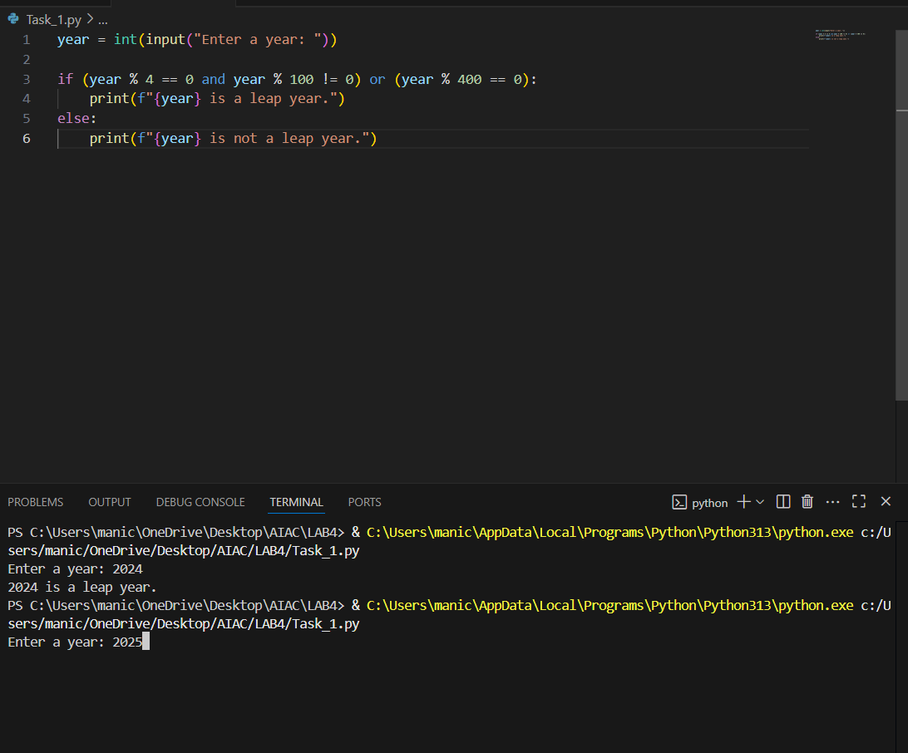

**Cursor:**

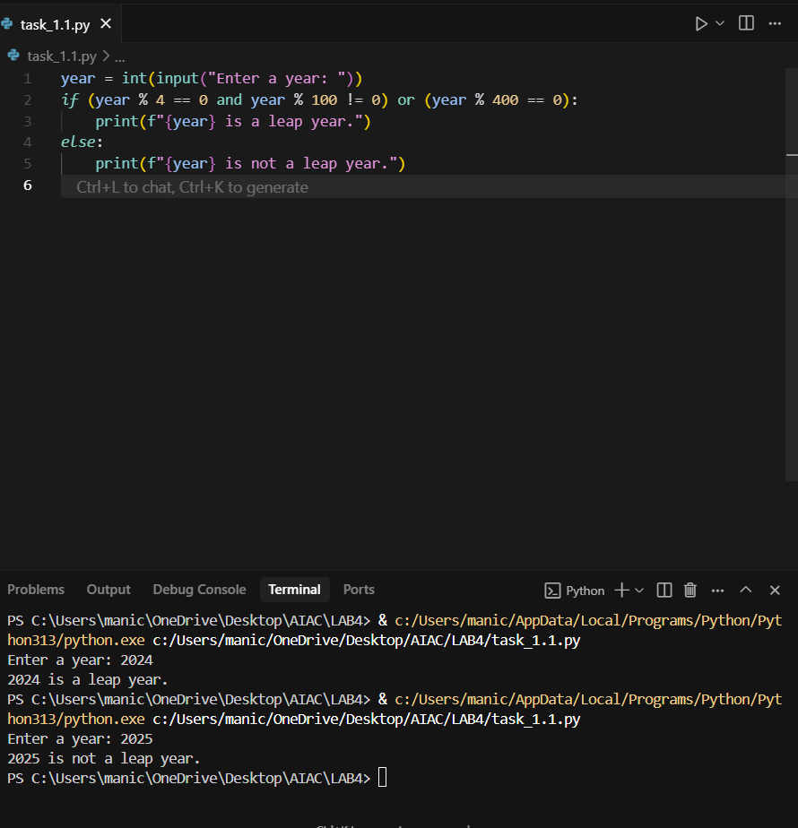

**Task Description#2**

* One-shot: Give one input-output example to guide AI in writing a function that converts centimeters to inches.

**Expected Output#2**

* Function with correct conversion logic

Prompt: Give me the python code to convert the centimeters to inches.Ask the user to give input.

Example: 1cm=0.3937 inches

10cm=10*0.3937

=3.937.

**VS Code:**

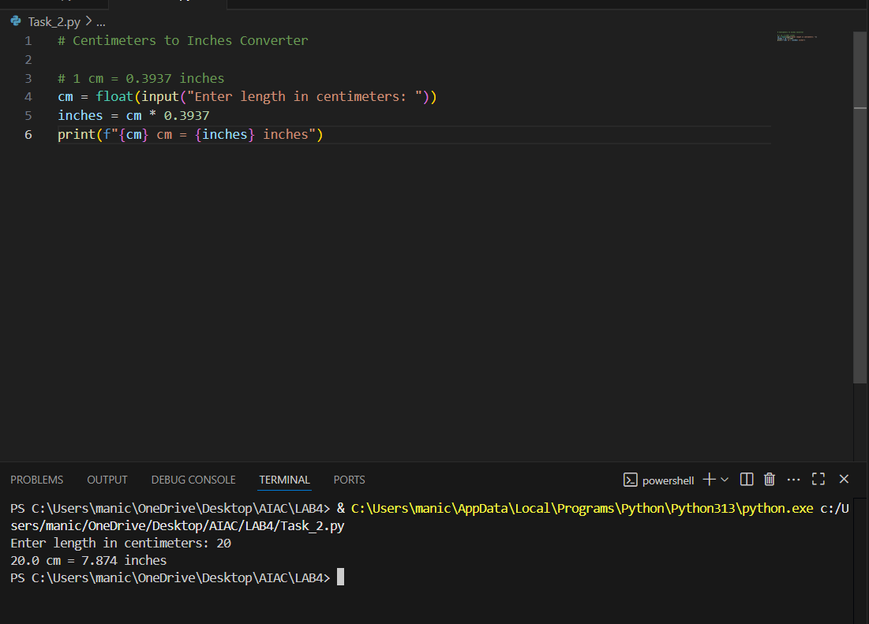

**Cursor:**

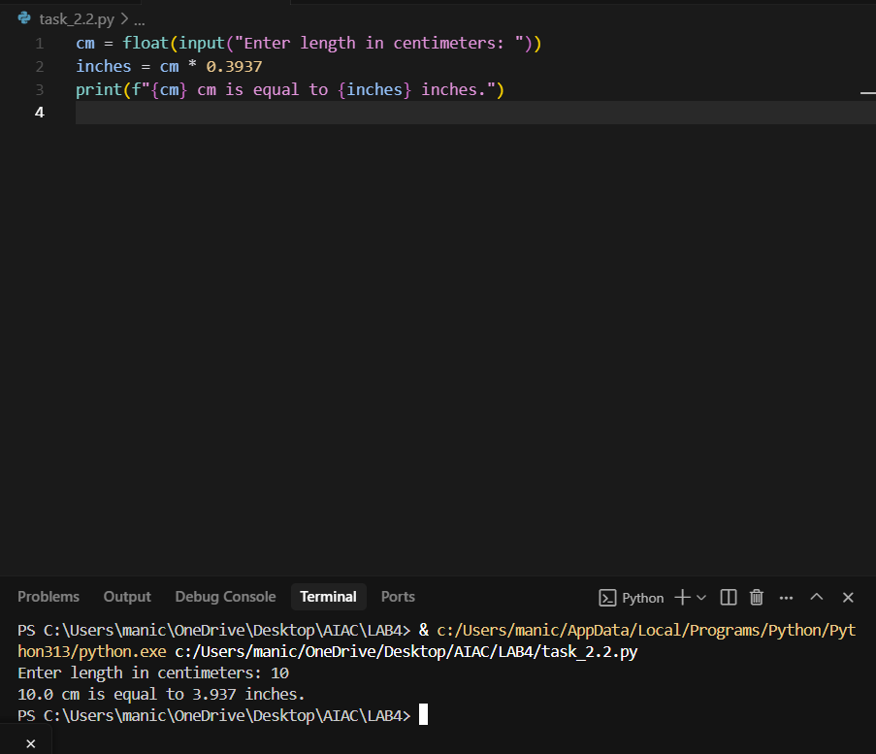**Task Description#3**

* Few-shot: Provide 2–3 examples to generate a function that formats full names as “Last, First”.

**Expected Output#3**

* Well-structured function respecting the examples

**Prompt:** Write a python function that takes first name and last name from the user and arrange last name as first and first name at end. Display final output on to the screen

Ex: first name:Mani

Last name: Chandana

Output:Chandana Mani

Ex2: first name:shari

Last name:Maneesha

Output:Maneesha shari

**VS Code:**

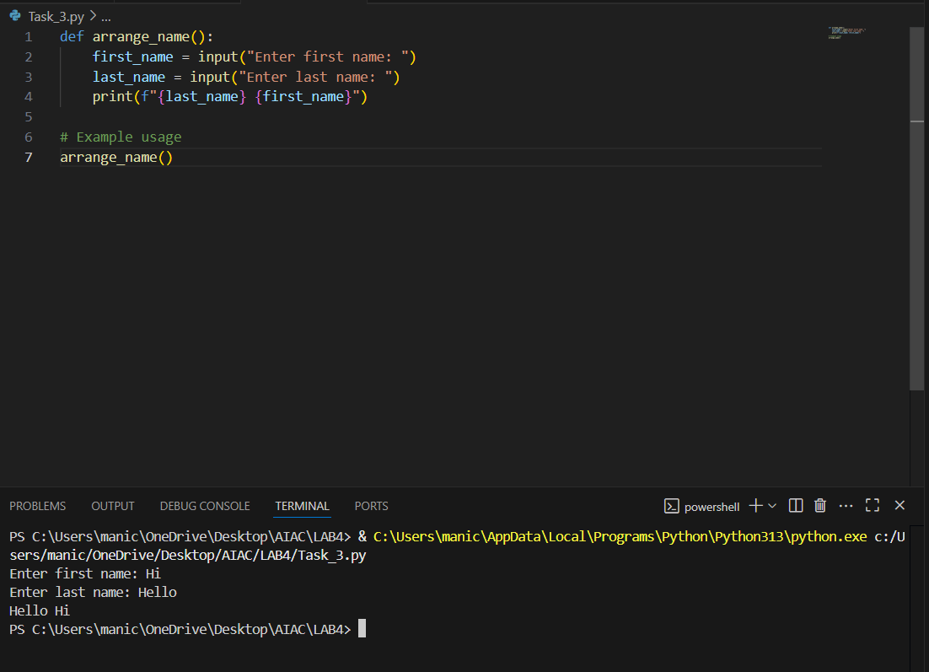

**Cursor:**

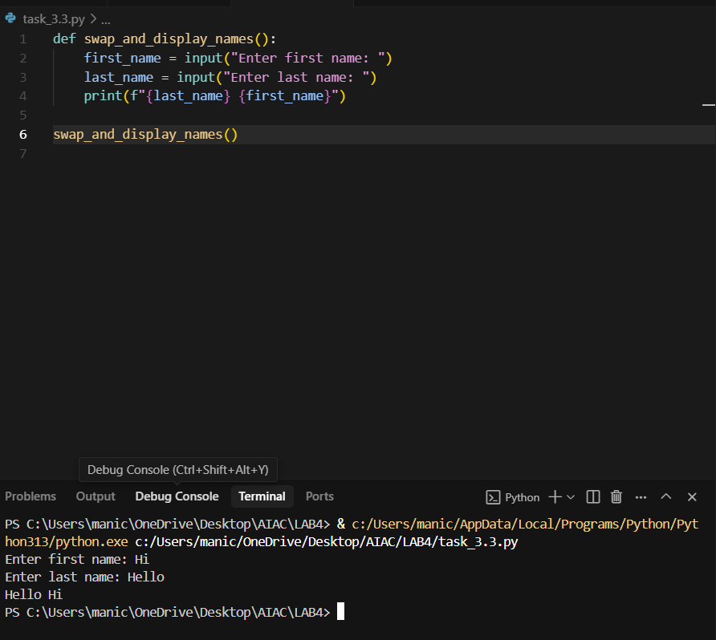

**Task Description#4**

* Compare zero-shot and few-shot prompts for writing a function that counts the number of vowels in a string.

**Expected Output#4**

* Functional output and comparative reflection

ZERO SHOT:

Prompt: Give me the python code to count the number of vowels in a string given by the user.

**VS Code:**

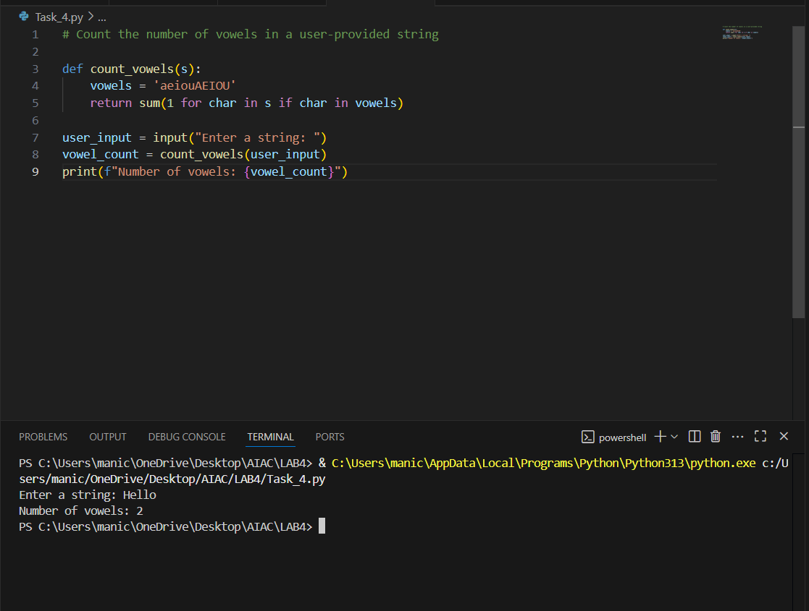

**CURSOR:**

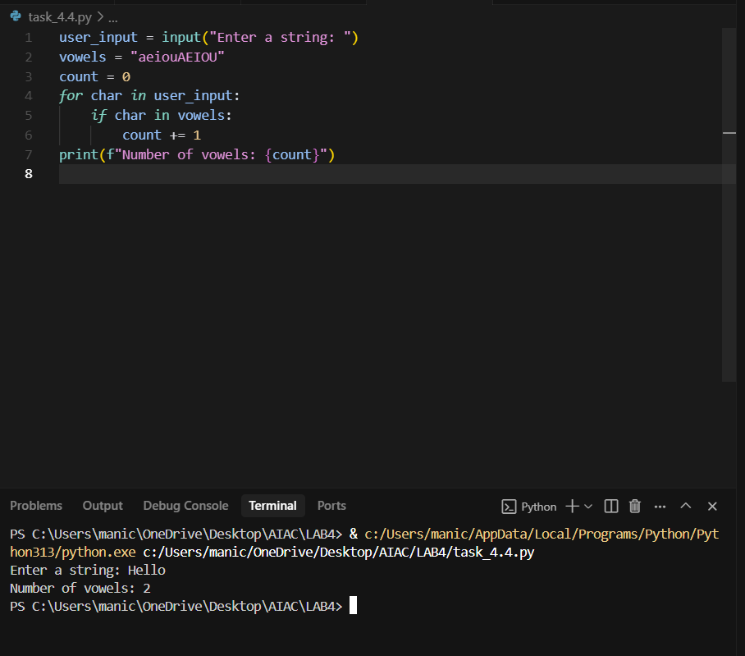

FEWSHOT:

Prompt: Give me the python code to count the number of vowels in a string given by the user. Display result on to the screen

Ex: Hi

Output: No.of.vowels=1

Ex2:Hello

Output:No.of.vowels=2

**VS Code:**

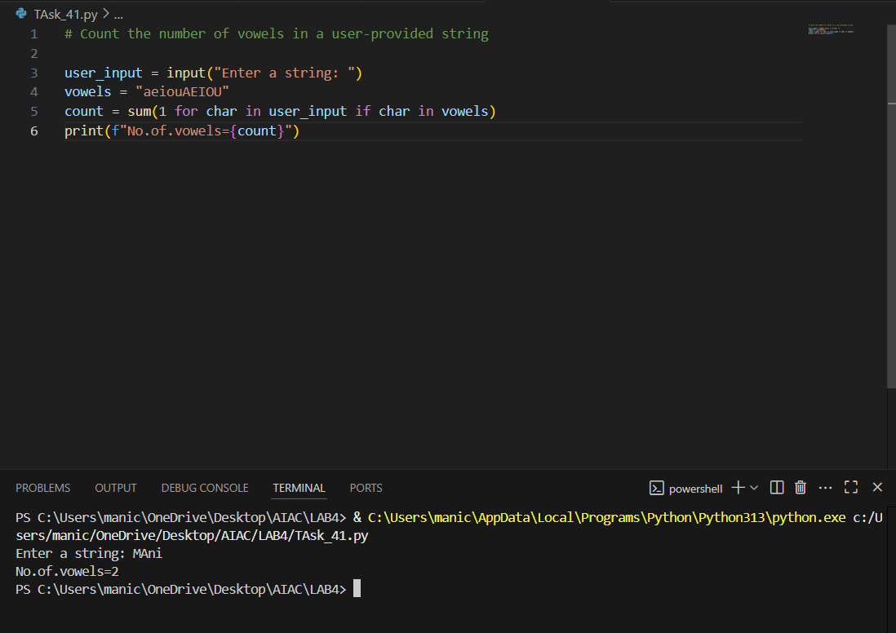

**CURSOR:**

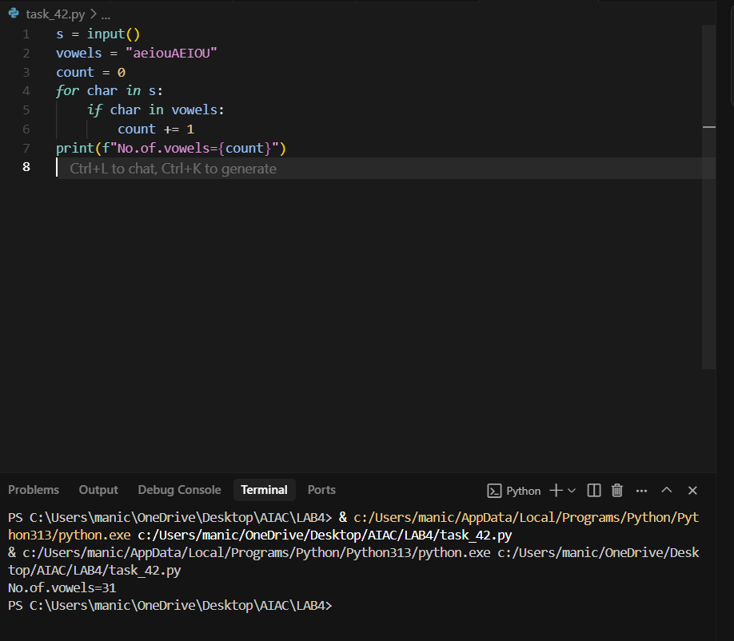

**Task Description#5**

* Use few-shot prompting to generate a function that reads a .txt file and returns the number of lines.

**Expected Output#5**

* Working file-processing function with AI-guided logic

Prompt: Write a python program to read the no of lines present in "C:\Users\manic\OneDrive\Desktop\poem.txt" file and display the result on to the screen.

**VS CODE:**

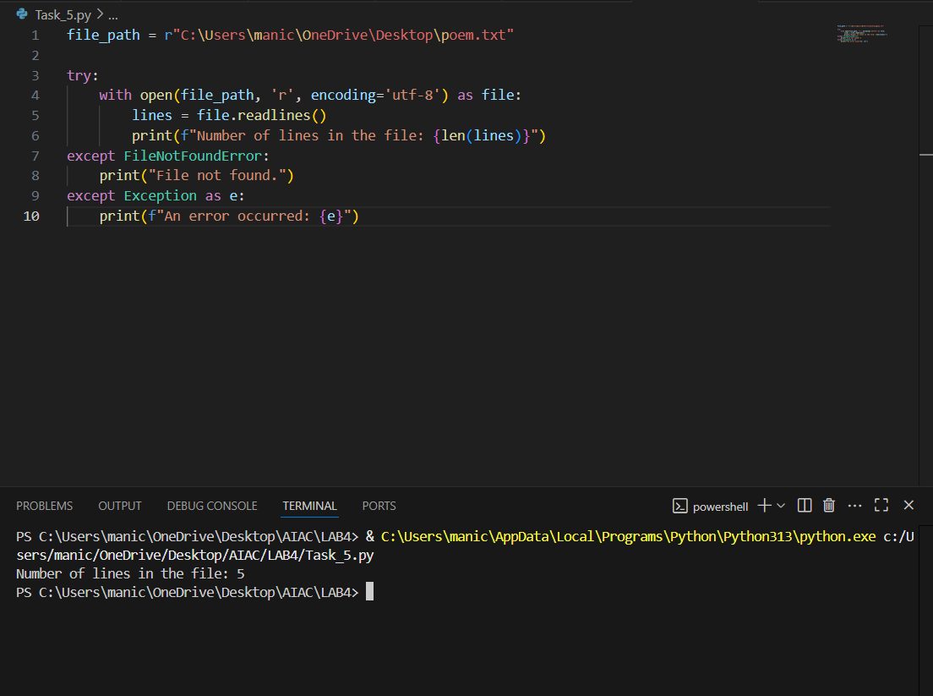

**Cursor:**

